Tode-RC .BD241S
Hardware Development

Arduino-Mega UI + Ebyte T20/30db RF

by TGit-Tech [ http://www.TGit-Tech.com ]
Tode-RC Model# BD241S / Last Updated: 2024-12-23

NOTES

TOTAL COST OVERVIEW
- Tode-RC Materials (Parts & Supplies) $33.57
  - Option Adjust for RF Radios @$10.77 base pricing
    - E22-900T30D: + $0.00
    - E32-433T30D: - $1.71
    - E22-400T30D: - $2.83
    - E32-433T20D: - $4.33
  - SMA Antenna Options
    - Omni 6cm 2dbi: $1.09/ea
    - Omni-folding 11cm 3dbi: $1.04/ea
    - Omni-folding 19cm 6dbi: $2.26/ea

- Labor Costs
  - djjfjfj

- Shipping Materials
  - dkdkdk

- Shipping
  - kdkdfjas

- Transaction Fees
  - Ebay
  - Etsy
  - PayPal

- Advertising Fees
  - Ebay
  - Etsy

BUNDLE MATERIAL COST $64.88
- (2) Tode-RC Materials $33.57/ea = $67.14
- (1) with Battery-Tray $ 1.51/ea = $ 1.51
- (1) with BIOPH $ 4.49/ea = $ 4.49

Table of Contents

Table of Contents
1. Table of Contents 3
2. Tode-RC $33.57 4
2.1 Keypad Assembly PCB.231Q $4.94 4
2.1.1 Materials 4
A. Parts $3.25 4
B. Supplies $1.34 4
C. 3D-Prints $0.35 4
2.1.2 Schematic & Layout 5
2.1.3 PCB Assembly 5
A. Push buttons 6
B. Pin Header 6
C. LED 6
2.1.4 Keypad Case 6
A. Heated Nuts Insert 6
B. Face Decals (Optional) 7
C. Drill-out Buttons 7
D. Cut-out Buttons 7
E. Mount Buttons 7
F. Fasten 8
2.2 Arduino Assembly $12.76 8
2.2.1 Materials 8
A. Parts $12.37 8
B. Supplies $0.20 8
C. 3D Prints $0.39 9
2.2.2 Arduino Shell 9
A. Arduino Mega-Pro in Plastic Shell 9
2.3 Ebyte-RF Assembly PCB.BD241S $15.87 9
2.3.1 Materials 9
A. Parts $14.44 9
B. Supplies $1.06 10
C. 3D-Prints $0.37 11
2.3.2 Schematic & Layout 12
2.3.3 Radio-PCB Assembly 13
A. Resistors 13
B. Arduino Sockets 14
C. Radio 14
D. CN3903 Power Supply 15
E. DC Barrel Jacks 15
F. Keypad-Display Plug 16
2.3.4 Radio Casing 16
2.4 Final Assembly $1.23 17
2.4.1 Materials 17
A. Supplies $1.23 17
2.4.2 Diagram 17
2.4.3 Casing Assembly 18
A. Radio Foil 18
B. Back-side Fasteners 18
C. Display Fasteners 18
D. Antenna 18
3. Battery-Tray Option $1.51 19
3.1 Materials 19
A. Supplies $0.86 19
B. 3D-Prints $0.65 19
3.1.2 Assembly 20
4. BIOPH Option $4.49 22
4.1.1 Materials $3.67 22
A. Parts $0.93 22
B. Supplies $1.14 22
C. 3D-Prints $0.78 22
4.1.2 DIN-Mount Materials $0.82 23
A. Parts $0.66 23
B. Supplies $0.16 23
4.1.3 Diagram 24
4.1.4 Assembly 25
A. Sockets in Front-Side 25
B. Front-Side on PCB 25
C. Pin Headers 26
D. Solder Pin Header Array 26
E. Attach Back-Side 26
F. (OPTION) Screw on DIN Brackets 27

Tode-RC $33.57

Keypad Assembly PCB.231Q $4.94

Materials

Parts $3.25
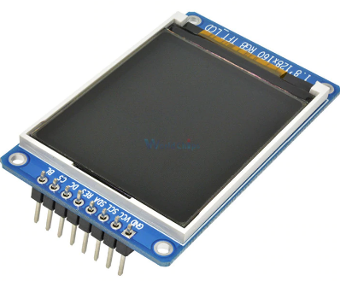  - 1.8 or 1.77 -Inch TFT LCD Display  - Power-In: 5Vdc  - Resolutions: 128 x 160dpi ST7735 RGB  - Dimensions: 35mm x 56mm  - Temp: -20C to 70C  - (8)Pin-Order: GND,VCC,SCL,SDA,RES,DC,CS,BL  - Pricing: $3.00/each (~4.38 to 2.64) | - Digital Keypad PCB version 231Q  - Manufacturer: jlcpcb.com  - Pricing Each: $0.25  - Batch Price: $20.93 per 100  - Zip Folder: JLCPCB-231Q-output

Supplies $1.34
 | (1) 1x8P Male Pin Header  PCB-J1, Dupont 2.54mm-Pitch  Cut from 40-Pin Male Pin Header  $0.01/pin = $0.08 |  | (6) 6x6-7mm Push Buttons  PCB-SW(1-6)  DIP-4 Tacticle Through-Hole  $0.15/ea = $0.90
 | (1) 47K 0805 SMT Resistors  PCB-R7  $0.01/ea = $0.01 |  | (1) 3mm Green LED  PCB-D1  $0.05/ea = $0.05
 | (2) M2x0.4-8 Flat Phillips  Machine Screw & Nut  Display & Keypad to Cover  $0.10/pair = $0.20 |  | (1) M2x0.04–20mm Machine Screw  Used as Heating stem ONLY  $0.10/ea = $0.10

3D-Prints $0.35

Tode-DispKB-3DShell.stl
Folder: .\Tode-RC\BD241S\3DPrints\stl\BD241S.3DDispKB.24CM.stl
Layer Height: 0.2mm
Infill Density: 100%
Supports: OFF
Plastic: 15-grams @ $0.02/g = $0.30
Printer-use: @ $0.0015/g = $0.0225
Power: 2h 29m @ $0.01/hr = $0.0248
TOTAL COST: $0.35

Schematic & Layout
SCHEMATIC | LAYOUT  D1 = 3mm Round Green LED  R7 = 47Kohm 0805 SMT Resitor  - 5V/47K = 0.1mA LED current.  SW(1–6) = 6x6x7mm Tactical Switches

PCB Assembly

Push buttons
- Push (6) 6x6x7mm Tactile Push buttons into PCB.
- Solder the push buttons to the PCB

Pin Header
- Cut and Insert a 8P male header
- Push pins down flush with top
- Solder back-side of pins

LED
- Solder a 47K-ohm 0805 SMT resistor
- Insert a 3mm Green LED (do not solder yet)
  - Short-lead in square-pad hole (GND)

Keypad Case

Heated Nuts Insert
- Thread a M2 nut onto just the very end of a long M2 Machine Screw (i.e. M2x0.04-20mm).

- Heat the Nut with a heat gun.

- Press the heated nut into the plastic as shown aligning the nuts shape with the shape in the casing.

- Using a screwdriver, press and drive the screw in, to clear excess plastic out the back-side then unscrew completely.

- Repeat for both nut locations under display opening

Face Decals (Optional)
- This step requires a cutting machine and special materials and design files.

- Contact Tgit-Tech if you'd like to purchase face stickers.
- DIY hobbyists can skip this step to create a unit without custom face stickers.

Fasten
- Place TFT display face-down on case first.

- Place Keypad with Buttons over the top and align holes.

- Fasten with (2) M2x0.4 – 8mm machine screws.

- Align LED with hole in casing.

- Solder the LED pins and clip excess off.

Arduino Assembly $12.76

Materials

Parts $12.37
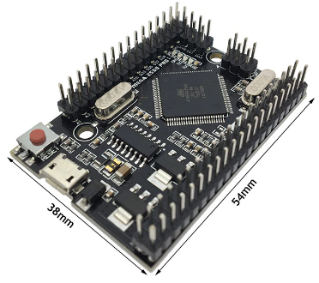 | Arduino Mega Pro Mini [ATmega2560]  - Size: 38Wx55Lmm  - Power In: 6Vdc to 9Vdc ( Peek 18Vdc )  - Power Out: 5Vdc @ 800mA + 3Vdc @ 800mA  - Load Amps: 5Vdc @ 220mA  - IO-Pins: 54-Digital, 16-Analog  - Memory: 256kb RAM, 4kb EEPROM  - Temp Rng: -40C to 85C  - 24CM-Pricing: $12.05/each  - Web @ https://robotdyn.com/mega-2560-pro-embed-ch340g-atmega2560-16au.html

Supplies $0.20
(2) M2.5x0.45 x 8mm Phillips-Flat Machine Screws & Nuts $0.32
Attaches Arduino Mega Pro Mini to 3D Casing
24CM-Pricing: (2) Screws @ $0.08/ea
24CM-Pricing: (2) Nuts @ $0.08/ea

3D Prints $0.39
ALL-AMPCenter.stl
Folder: \All-3DPrints\stl

PLA Filament: 17g @ $0.02/g = $0.34
Printer-use: 17g @ $0.0015/g = $0.0255
Power: 2h 23m @ $0.01/hr = $0.025

TOTAL COST: $0.39

Arduino Shell

Arduino Mega-Pro in Plastic Shell
Fasten the Arduino Mega Pro Mini with Male Pin Headers into the 3D Printed case using (2) M2.5x0.45 – 8mm flat-head machine screws with nuts on Arduino side.

Be sure not to damage components next to the top nut while tightening.

Ebyte-RF Assembly PCB.BD241S $15.87

Materials

Parts $14.44
(1) BD241S PCB (Back-plane)
- File Location: \Tode-RC\BD241S\kicad
\BD241S-Backplane
\Final_JLCPCB-241S.zip
- Manufacturer: jlcpcb.com
- Batch Price: $46.11 per 75
- Pricing: $0.61/ea = $0.61
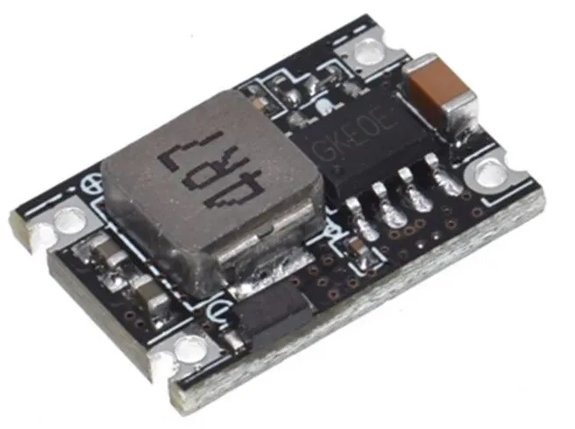 | (1) CN3903 DC-DC Buck Step-Down Board 5V@3A  - Voltage: 5Vdc to 30Vdc Input to 5Vdc Output  - Size: 17.5mm x 12mm x 4.3mm (LWH)  - Max Output: 3A  - 24CM-Pricing: (10pcs) $7.99 = $0.80
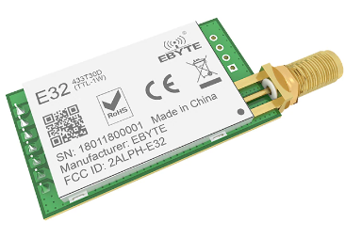 | (1) Ebyte Radio (Various T20D/T30D Options)  - E22-900T30D Pricing: $10.77/ea  - E22-400T30D Pricing: $7.94/ea  - E220-400T30D Pricing: $10.07/ea  - E32-433T30D Pricing: $9.06/ea  - E32-433T20D Pricing: $6.44/ea  - Website: https://www.cdebyte.com/Module-Lora
(1) SMA Aerial Antenna (Various Options)
  - Omni 6cm 2dbi: $1.09/ea
  - Omni-folding 11cm 3dbi: $1.04/ea
  - Omni-folding 19cm 6dbi: $2.26/ea
Estimated Price $2.26/ea

Supplies $1.06
 | (1) 2x7P Pin Socket  Dupont 2.54mm-Pitch  Backplane PCB  $0.18/ea = $0.13 |  | (1) 2x8P LONG-Lead Socket  Dupont 2.54mm-Pitch  Keypad & Display Connect  $0.15/ea = $0.15
 | (1) 2x4P Pin Socket  Dupont 2.54mm-Pitch  Radio, Buttons & IO  $0.17/ea = $0.17 |  | (1) 1x4P Pin Header  Dupont 2.54mm-Pitch  Radio Ground Stubs  $0.01/pin (from 40-pin cut) = $0.04
 | (1) 2x3P Pin Socket  Dupont 2.54mm Pitch  ICSP and Power  $0.10/ea = $0.12 |  | (4) 1x1P Pin Header  Dupont 2.54mm-Pitch  Radio Ground Stubs  $0.01/pin (from 40-pin cut) = $0.04
 | (2) #2-1/4” Screw  PCB to Casing  Phillips-Flat Sheet Metal Screw  $0.10/each = $0.20 |  | (2) 5.5x2.1-9mm DC Barrel Jack PCB  Female PCB Mount  3-Terminal, 9mm Connector Depth.  $0.08/ea = $0.16
 | (1) 2.2KΩ 0805 SMT Resistor  PCB-R3  $0.01/ea = $0.01 |  | (2) 4.7KΩ 0805 SMT Resistors  PCB-R1 & R2  $0.01/ea = $0.02
(2) 10Ω 0805 SMT Resistors
PCB-R4 & R5
$0.01/ea = $0.02

3D-Prints $0.37
BD241S-Backplane.24CM.stl
Folder: \BD241S\3DPrints\stl

PLA Filament: 16g @ $0.02/g = $0.32
Printer Use: 16g @ $0.0015/g = $0.024
Power: 2h 36m @ $0.01/hr = $0.025

TOTAL COST: $0.37

Schematic & Layout
SCHEMATIC | LAYOUT  J1 – Arduino PWR – 2x3P Socket  J2 – Arduino ICSP – 2x3P Socket  J3 – Generic Test-Points  J4 – Ebyte T30D Radio Connections  J5 – DispKB Connections  J6 – PWR Test-Points  J7 – Arduino Radio, Key, TFT Connections  J8 – Input Barrel Jack (7-30Vdc)  J9 – Output Barrel Jack (5Vdc)  J10, J11, J12, J13 – CN3903 Power Supply  J14 – Ebyte T20D Radio Connections  R1,R2 - 4.7KΩ Rx,Tx Resistors  R3 – 2.2KΩ Arduino D13 Pull-up on OK keypad.  R4,R5 – 10Ω Jumpers

Radio-PCB Assembly

Resistors
Solder Resistors on PCB
- R1 = 4.7KΩ above Ebyte-J14
- R2 = 4.7KΩ above Ebyte-J14
- R3 = 2.2KΩ side of ICSP Bottom
- R4 = 10Ω side of ICSP Top
- R5 = 10Ω above Ebyte-J14, Right-side

TEST – using Ω-meter test
- (Rx) YELLOW to YELLOW = 4.7KΩ
- (Tx) GREEN to GREEN = 4.7KΩ
- (M1) BLUE to BLUE = 10Ω
- YELLOW to GREEN = No-Connection

Refer to Shematic & Layout for specifics.

Arduino Sockets

- Attach Dupont Sockets to Arduino
- J1 = (1) 2x4P Left-Top Arduino
- J7 = (1) 2x7P Left & 7-Rows down
- J2 = (1) 2x3P on Arduino ICSP Header

- Place BD241S PCB on Socket Pins.

- Solder Dupont Sockets to PCB.

- Unplug the PCB from Arduino.

Radio
- Place Pin Header into Top of PCB.
  - For T20D radios use 1x3P Header
  - For T30D radios use 1x4P Header

- Place Radio onto PCB.

- Solder Radios 7-Pins to PCB.
- Solder the 1x3P or 1x4P Pins to PCB.

- Trim excess Pin Length from back PCB.

CN3903 Power Supply
- (4) 1x1P Headers into Bottom of PCB.

- Place CN3903 Power Supply Module as pictured with its coil-block facing the PCB screw-hole (fatter-side).

- Solder Pins to PCB and Power Supply.

DC Barrel Jacks
- Solder (1) Barrel Jack (Power-IN) pointing down on skinny-side.

- Solder (1) Barrel Jack (IO-Power) pointing to the PCB edge on the fat-side/ screw-hole-side of the PCB.

Component white footprint on PCB can help verify barrel jack direction.

Keypad-Display Plug
- Plug the AMP-Center into PCB.

- Insert 2x8P Long-Leg Female Header into PCB.

- Place and align pins of the Keypad-Display to plug into the 2x8P Back-plane Plug.

- Use Pinch method and Thumb to press the 2x8P plug into the Keypad-Display.

- Align the Assemblies then solder the 2x8P plug to the PCB. Consider screwing the Keypad top-screws to the AMP-Center to help align.

- Trim excess lead length from back of PCB.

Radio Casing
- Unplug PCB and insert into casing putting the radio antenna through the hole first.

- Make sure PCB is pressed down against Back-plane casing completely then use (2) #2-1/4 screws to secure.

Final Assembly $1.23

Materials

Supplies $1.23
 | (4) #2 x 3/8” Screws  Display to Center  Phillips-Pan Sheet Metal Screw  $0.10/ea = $0.40 |  | Aluminum Foil  Approximately 1/2sqft  $0.06/sqft = $0.03
 | (4) #2 x 1/2” Screw  Backplane to Center  Phillips-Flat Sheet Metal Screw  Sheet Metal Screw  Price $0.06/ea = $0.24 |  | 2-Inch Clear Packing Tape  Aluminum Foil Insulation

Diagram

Casing Assembly

Radio Foil
- Cut a rectangle of Aluminum Foil 27mm x 48mm.

- Cut a section of 2-Inch Clear Packing Tape at least 100mm long.

- Place the rectangle of Aluminum Foil on the sticky-side bottom end of the 2-Inch Packing Tape.

- Wrap the tape completely around the Aluminum Foil

- Cut/Trim the Tape edge a hair away from the Aluminum edge to prevent any aluminum exposure.

- Place the tape-insulated aluminum foil over the Ebyte Radio as shown to prevent High-Power transmits from causing Arduino reboots.

Back-side Fasteners
- Plug the AMP (Arduino Mega Pro) Center to the 1W-Backplane assuring correct pin alignment.

- Using (4) #2-1/2” Phillips-Flat Screws fasten the Backplane (back-side) to AMPCenter.

Display Fasteners
- Plug the DispKB into the (front-side) Backplane assuring correct pin alignment and casing alignment with Center.

- Using (4) #2-3/8 Phillips-Pan Screws fasten the Display Casing to the Top.

Antenna
Attach an antenna to the SMA-K connector.

Battery-Tray Option $3.00

Materials

Supplies $2.06
 | (1) 5.5x2.1mm Barrel Plug  9mm Insert (!NO Longer!)  $0.11/ea = $0.11 |  | (1) 9V Battery Clip  Hard Plastic Side-Exit Wires  $0.35/ea = $0.35
 | (2) #4 x 3/4” Screws  Barrel Plug Clamp  Phillips-Pan Sheet Metal Screw  $0.10/ea = $0.20 |  | (1) KCD11 3A Rocker Switch  SPST 10x15mm  $0.10/ea = $0.10
 | (1) #4 x 3/8” Screw  Battery Cover  Phillips-Flat Sheet Metal Screw  $0.10/ea = $0.10 | 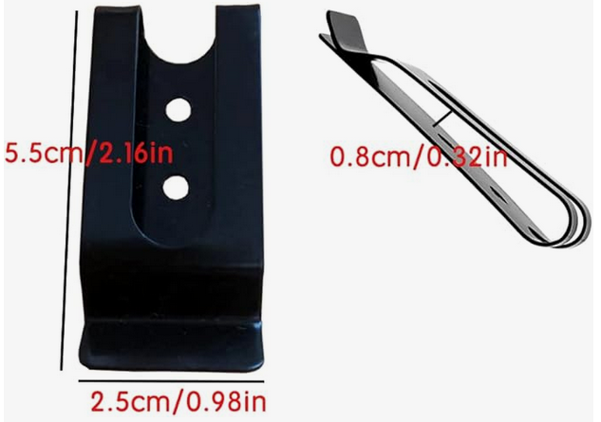 | (Optional) Belt Clip  55(2.6”)x25(0.98”)mm Metal  0.25” hole spacing (3mm dia)  $0.80/ea = $0.80
(2) M2.5x0.45 – 5mm Flat
Belt Clamp
Phillips-Pan Machine Screw
$0.20/ea = $0.40

3D-Prints $0.94
File: 9V1W.3DTray.24CS.stl
Folder: .\Tode-9V-Batt\1W\3DPrints

Layer Height: 0.2mm
Infill Density: 100%
Supports: OFF

Plastic: 32-grams @ $0.02/g = $0.64
Printer-use: @ $0.0015/g = $0.048
Power: 4h 42m @ $0.01/hr = $0.047
TOTAL COST: $0.735
File: 9V1W.3DClamp.24CS.stl
Folder: \Tode-9V-Batt\1W\3DPrints

Layer Height: 0.2mm
Infill Density: 100%
Supports: OFF
Plastic: 3-grams @ $0.02/g = $0.06
Printer-use: @ $0.0015/g = $0.0045
Power: 0h 42m @ $0.01/hr = $0.007
TOTAL COST: $0.0715
File: 9V1W.3DCover.24CS.stl
Folder: \Tode-9V-Batt\1W\3DPrints
Layer Height: 0.2mm
Infill Density: 100%
Supports: OFF
Plastic: 6-grams @ $0.02/g = $0.12
Printer-use: @ $0.0015/g = $0.009
Power: 0h 48m @ $0.01/hr = $0.008
TOTAL COST: $0.137

Assembly
Prepare 9V Battery Clip
- Cut Red wire 50mm long.
- Cut Black wire 80mm long.
- Cut a piece of Red wire 50mm long.
Strip, Clamp and Solder the black wire to the Barrel Plugs long lead.
Solder the Battery Clip Red wire to one of the rocker switches terminal.

Solder the piece of 50mm Red wire (3.) to the other switches terminal on one end and the Barrel plug short lead. to the other end. Putting the switch in the Red wires path as shown.
Route the Barrel Plug and Battery Clip through the switch hole and push the switch into the casing.

Put the barrel plug in the casing and route wires as shown.
Using (2) #4 - 3/4” Phillips-Flat Screws attach the Clamp to hold the Barrel Plug into place.

Clip on a battery and stuff the wires in the pocket over the switch.

Install the
Using (1) #4 – 3/8” Phillips-Flat Screw attach the Cover over the battery.

BIOPH Option $4.49

Materials $3.67

Parts $0.93
- IO-Access 23BF PCB
  - Design Software: Kicad
  - Folder: \Tode-IO\Tode-BIO\kicad\IO-ACCESS\SIOST
  - Manufacturer: jlcpcb.com
  - Batch Price: $46.43 per 50
  - Pricing: $0.93/ea

Supplies $1.14
 | (2) 2x40P Male Pin Header  Dupont 2.54mm-Pitch  PCB Pin-Header Array  @$0.21/ea = $0.42 |  | (2) 1x16P Long Leg Socket  Dupont 2.54mm-pitch  PCB Analog-IO Tode-Side  @0.17/ea = $0.34  – OR –  (2) 2x8P Long Leg Sockets  @0.15/ea = $0.30
 | (1) 2x3P Long Leg Socket  Dupont 2.54mm-pitch  PCB Digital-IO Tode-Side  @0.12/ea = $0.12 |  | (1) 2x4P Long Leg Socket  Dupont 2.54mm-pitch  PCB Digital-IO Tode-Side  @0.14/ea = $0.14
(4) #4 x 3/8”Phillips-Flat Screw
Front-Side to Back-Side
$0.03/ea = $0.12

3D-Prints $0.78

BIOPH-FrontSide.stl
Folder: ./Tode-IO-Options/Side-IO Commercial Box/3DPrints/stl
Layer Height: 0.2mm
Infill Density: 100%
Supports: OFF
Plastic: 9-grams @ $0.02/g = $0.18
Printer-use: @ $0.0015/g = $0.0135
Power: 1h 43m @ $0.01/hr = $0.0175
TOTAL COST: $0.21
BIOPH-BackSide.stl
Folder: ./Tode-IO-Options/Side-IO Commercial Box/3DPrints/stl
Layer Height: 0.2mm
Infill Density: 100%
Supports: OFF
Plastic: 25-grams @ $0.02/g = $0.50
Printer-use: @ $0.0015/g = $0.0375
Power: 3h 07m @ $0.01/hr = $0.03
TOTAL COST: $0.57

DIN-Mount Materials $0.82

Parts $0.66
(2) DIN Mount Brackets
DRG-01 for 35 x 7.5mm DIN Rail
Pricing: $0.33/ea = $0.66

Supplies $0.16
(4) #4 x 5/8”Phillips-Flat Screw
Standoff-Label
$0.04/ea = $0.16

Diagram

Assembly

Sockets in Front-Side

- Press (2) 1x16P Long Leg Sockets into Front-Side 3DPrint.

- Insert (1) 2x3P and (1) 2x4P Long Leg Dupont Sockets into Front-Side 3DPrint.
  - Sand the socket ends for a proper fit.

Front-Side on PCB

- Press Front-Side with installed Pin Sockets into the PCB holes.

- Plug in an Arduino Mega-Pro for correct plug alignment.

- Solder the Sockets to the PCB.

- Trim excess Pin Length

Pin Headers

- Cut (2) 2x40P Pin Headers to 32-Pin Lengths to fit the Pin Header Array.

Solder Pin Header Array

- Install the (2) 2x23-Pin Headers into the PCB.

- Using (3) 1x4P Sockets keep Pin Header array pins straight.

- Solder all pins to PCB.

Attach Back-Side

- Place Front-Side assembly on Back-side 3D Print as pictured.

- Fasten with (4) #4 x 3/8in Flat-Head SMS screws.

(OPTION) Screw on DIN Brackets

- Using (4) #4 x 5/8in Flat-Head SMS screws attach the DIN brackets with their pry-release tabs facing the bottom to the BIOPH Assembly.

- Attach to desired DIN Rail.

